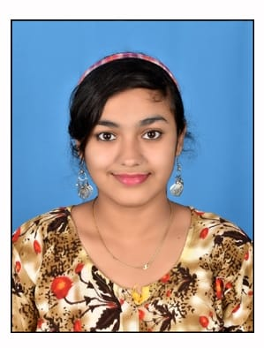

**SHAIK SHAJOON**

**Mobile No:** 8332853670

**Email ID:** [shajoonshaik@gmail.com](mailto:shajoonshaik@gmail.com)

**CAREER OBJECTIVE:**

Pursuing knowledge and utilizing skills in organization to flourish in my professional life and live up to the organizational demands and responsibilities.

**ACADEMICS:**

|  |  |  |  |  |
| --- | --- | --- | --- | --- |
| Qualification | School/College | **Board/University** | Year of pass | Percentage |
| B,Tech(CSE) | Ravindra College of engineering for women | JNTUA | 2020-2024 | Ongoing |
| Intermediate | Sri Chaitanya Junior College | Board of intermediate | 2018-2020 | 92 |
| SSC | Sri Chaitanya EM high school | Board of secondary education | 2018 | 100 |

**SKILL SETS:**

* **Professional Skills:**
* Communication skills
* Time management skills
* Teamwork and collaboration.
* Active listening skills
* **Technical Skills:**
* C
* Python(Basics)
* **Operating Systems:**
* Windows
* Ubantu
* **Office/Infographic tools:**
* Microsoft word
* Microsoft excel
* **Data Base:**
* Database Management Systems

**Strengths:**

* **Good communication skills**
* **Multitasking**
* **Honesty**
* **Team work**
* **Enthusiasm**
* **Self-Confident**

**ACHIVEMENTS:**

* Certified in Introduction to Networks from Cisco Networking Academy.
* Certified in Switching, Routing, and Wireless Essentials
* Certified in Salesforce Developer Virtual
* Certified in Cyber Security Essentials
* Certified in Microsoft Azure Fundamentals (AZ-900)

**PERSONAL DETAILS:**

**Date of birth:** 24-06-2003

**Father Name:** SHAIK SHABBIR

**Mother Name:** S SHAHEEN BEGUM

**Current Address:** Prakash Nagar, Kurnool

**Permanent Address:** Prakash Nagar, Kurnool

**Hobbies:** Travel, Photography, Playing games, Cooking

**Nationality:** Indian

**Language known:** English, Hindi, Telugu

**Any kind of disability:** No

**Willingness to Relocate:** Yes

**DECLARATION:**

I hereby declare that all the above-mentioned information is true and correct to the best of my knowledge.

**Place: Kurnool. Signature: SHAIK SHAJOON.**